Problem Assignment #2
Opcode Decoder
ECE 2330 Digital Logic Design
Spring 2022
February 6, 2022
By Kevin Moody (km4ws)

Table of Contents
1 Problem Statement 2
2 Analytical Design 2
3 Numerical Verification 4
4 Summary 5

Table of Figures
Figure 1: Sample CPU Instruction Format 2
Table 1: Simple CPU Instructions 2
Figure 2: Outer Circuit for Opcode Decoder 3
Figure 3: Inner Circuit for Opcode Decoder 3
Figure 4: Truth Table for Opcode Decoder 3
Figure 5: All Possible Solutions for Opcode Decoder 4
Figure 6: Input Test Vectors 4
Figure 7: Test Results (Table) 5
Figure 8: Test Results (Graph) 5

1 Problem Statement
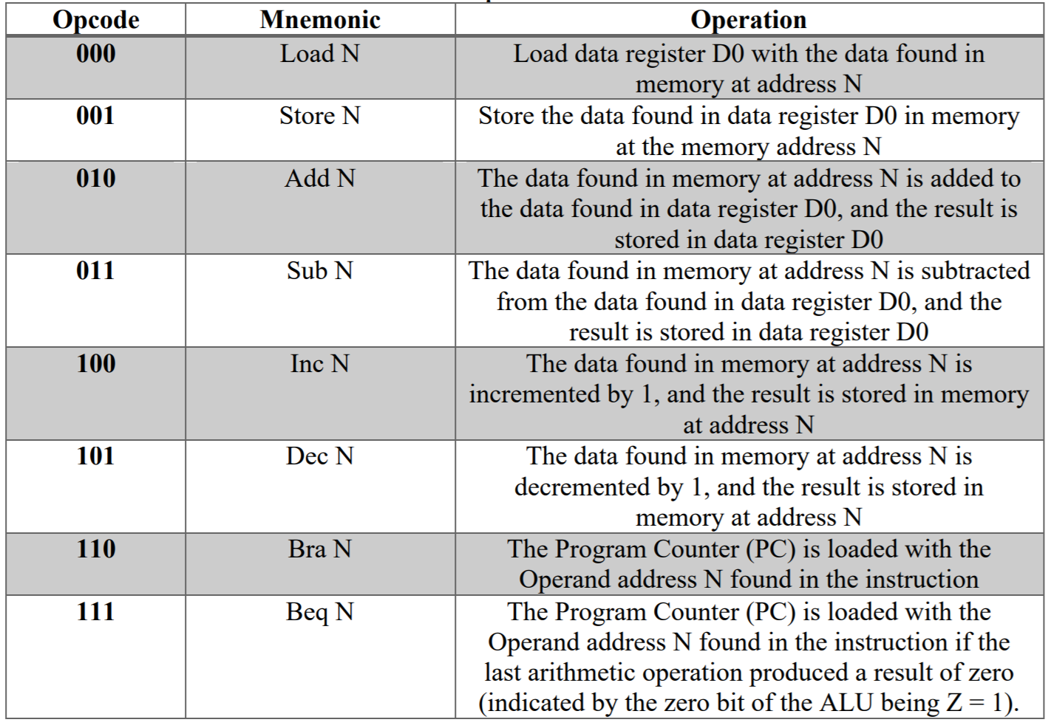
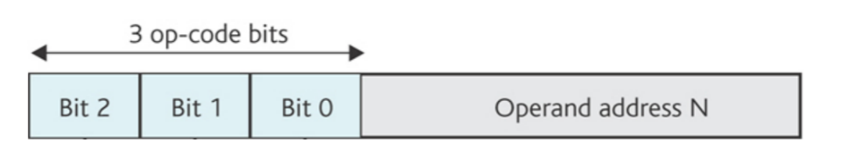
Design a digital decoding circuit to decode the 3-bit opcode for the instruction format shown in Figure 1, with the 8 instructions listed in Table 1.
Table 1: Simple CPU Instructions
Figure 1: Sample CPU Instruction Format

2 Analytical Design
The outer and inner circuit schematics for the opcode decoder are shown in Figures 2 and 3 respectfully. The yellow box in the outer circuit contains the schematic shown in the inner circuit. The truth table for the opcode decoder is shown in Figure 4.

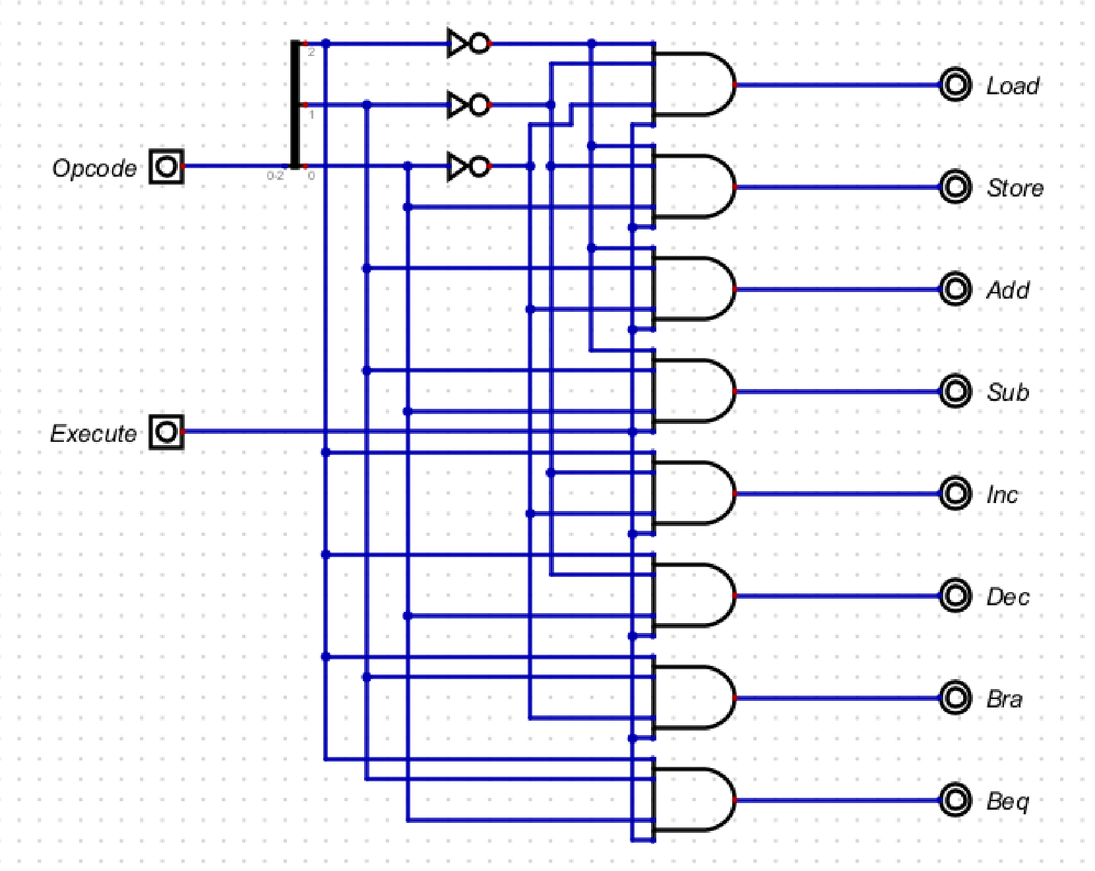
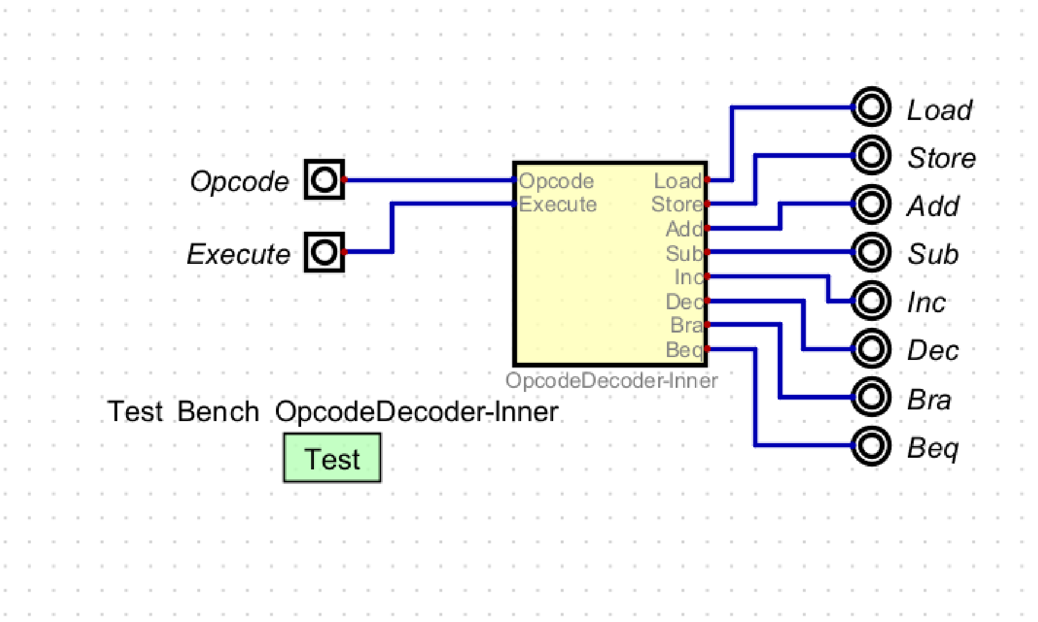
Figure 2: Outer Circuit for Opcode Decoder
Figure 3: Inner Circuit for Opcode Decoder
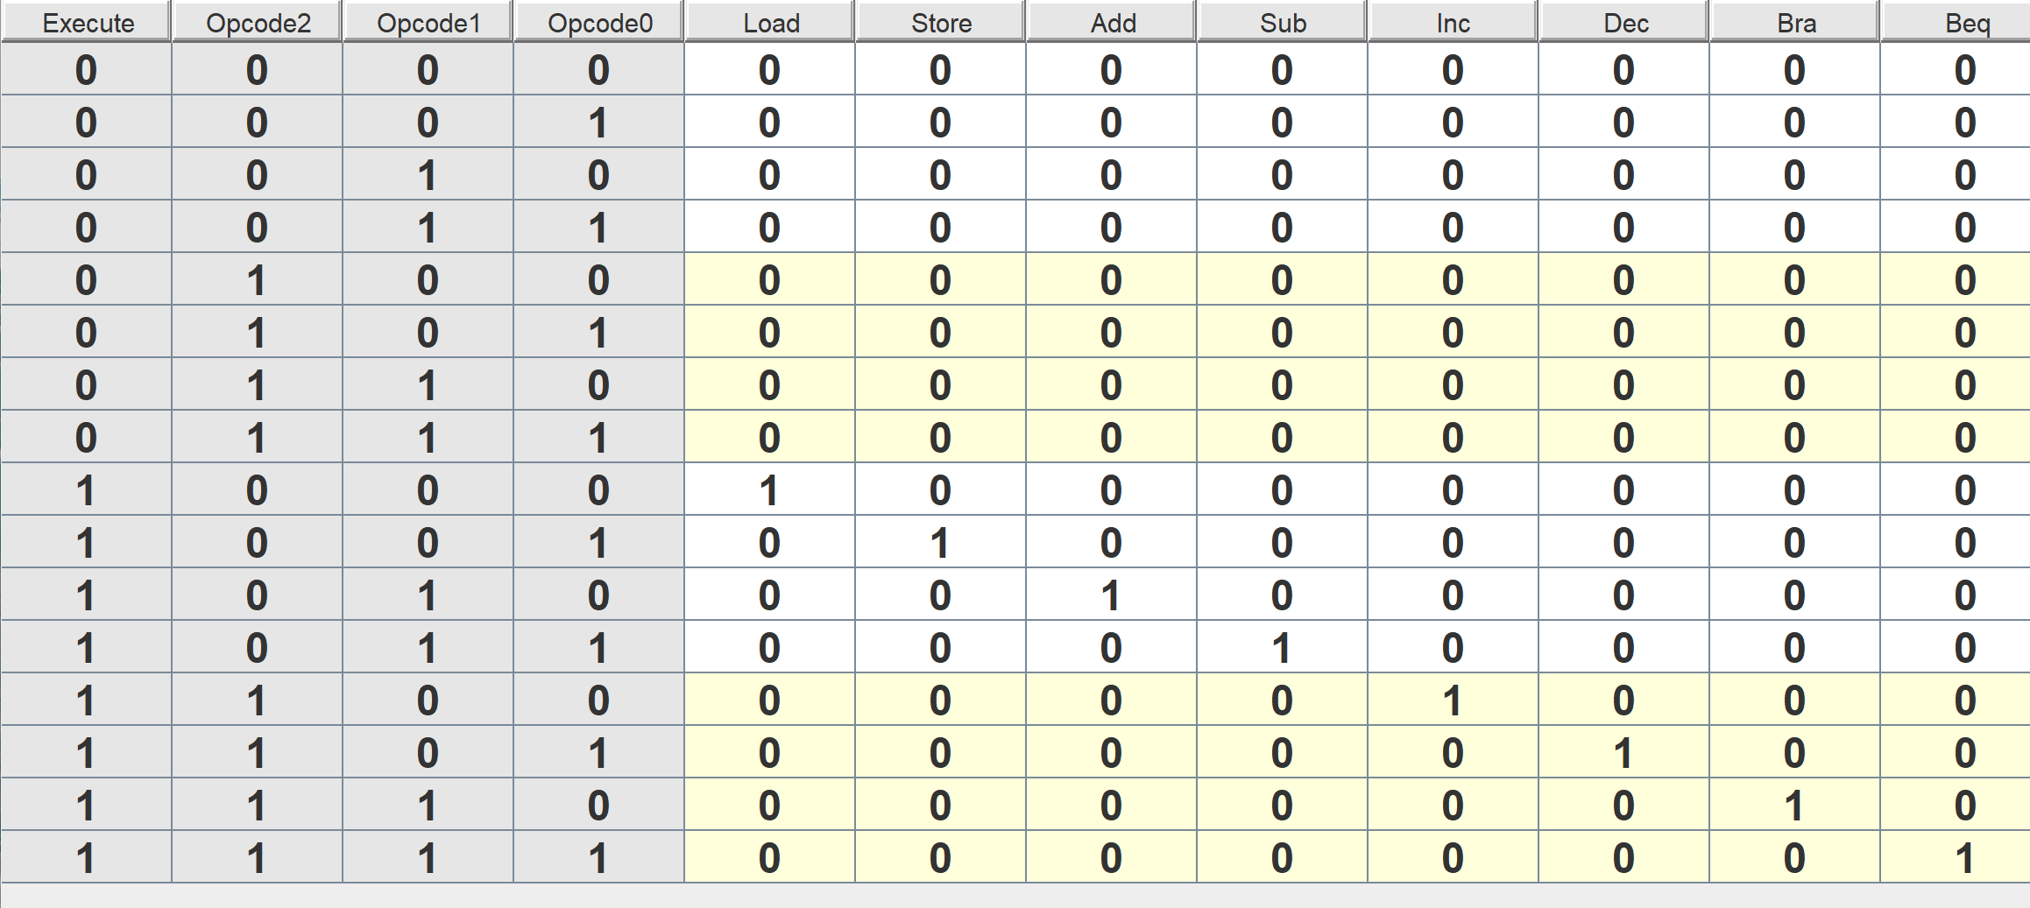
Figure 4: Truth Table for Opcode Decoder
Notice that for the truth table, none of the outputs (Load, Store, Add, Sub, Inc, Dec, Bra, Beq) are 1, unless Execute is 1 as well. The Opcode values line up with their expected output according to Table 1 (i.e. Opcode 2 = 0, Opcode 1 = 1, and Opcode 0 = 1 will result in Sub = 1 as long as Execute is 1). The list of all possible solutions can be found in Figure 5, which further confirms the results from Figure 4.

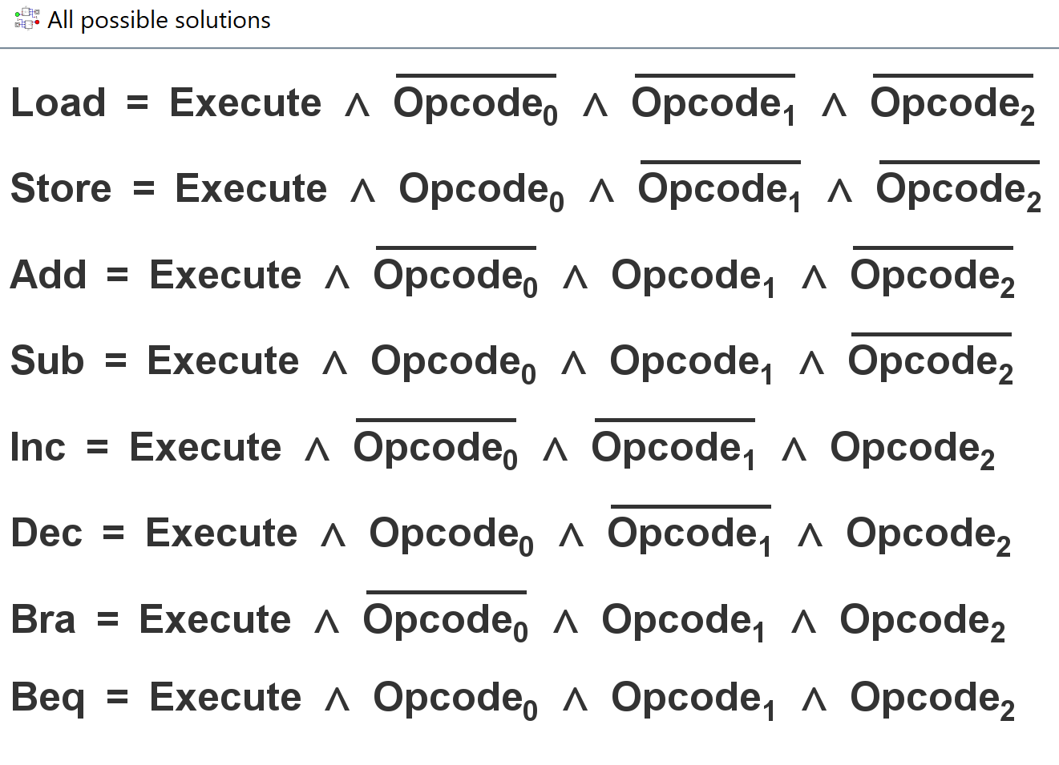
Figure 5: All Possible Solutions for Opcode Decoder
3 Numerical Verification
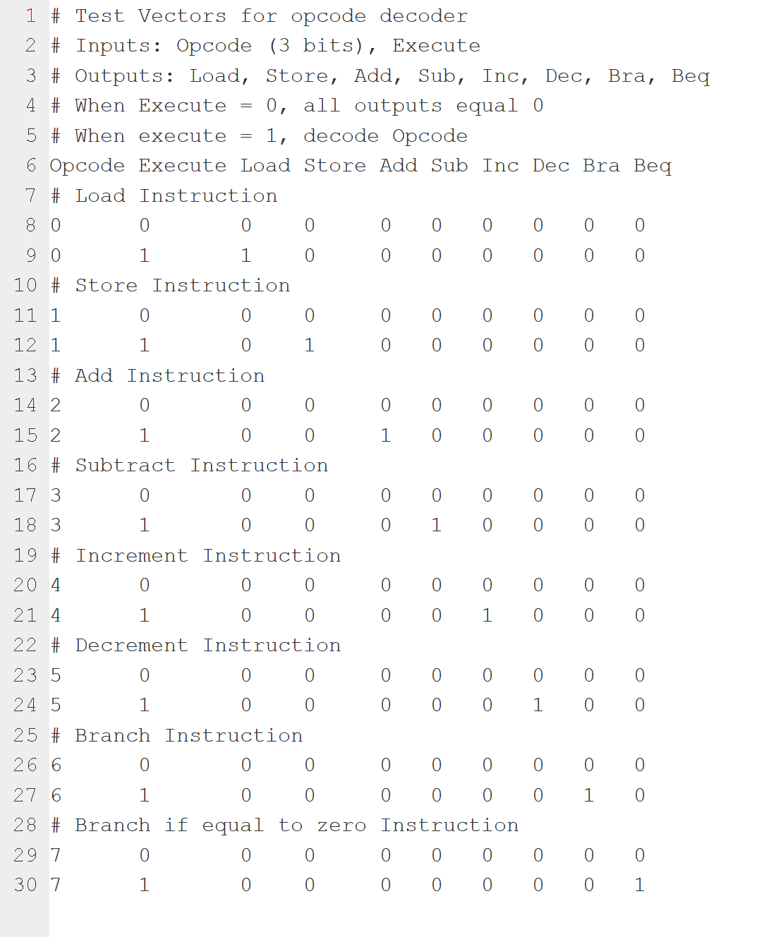
Shown in Figure 6, Figure 7, and Figure 8 are the numerical verification results, where an exhaustive set of test vectors (Figure 3) were applied to the circuit.
Figure 6: Input Test Vectors
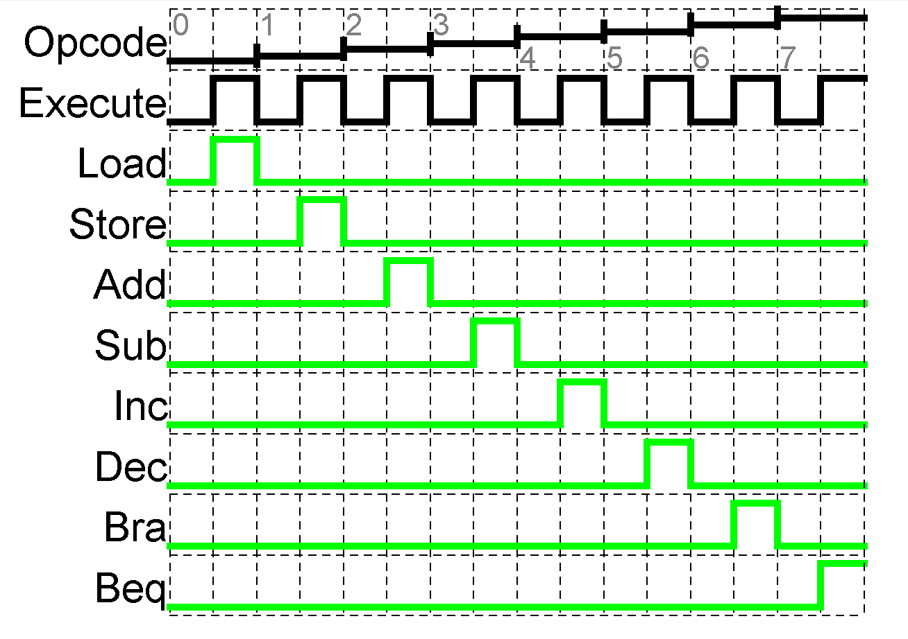
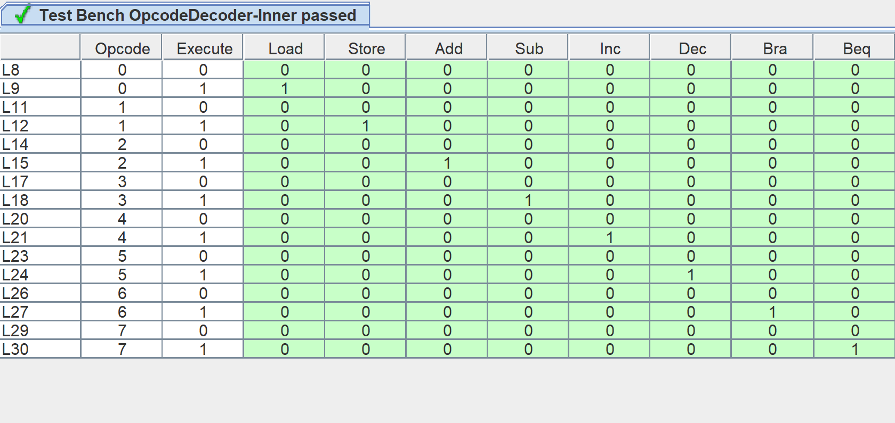
4 Summary
Figure 8: Test Results (Graph)
Figure 7: Test Results (Table)
The problem requirement for this assignment was to design an opcode decoder circuit, that produces an output signal based on the opcode and execute inputs. If the execute signal is equal to 0, the output is 0. If the execute signal is 1, the circuit uses the opcode to decide which signal to send out, according to the instructions in Table 1.
A truth table was used to develop a list of possible solutions for the opcode decoder, which was then used to design a digital circuit solution. The circuit solution was then tested with an exhaustive set of input test vectors (16 test vectors for 4 inputs; 3 from opcode, 1 from execute), and produced the expected output for each test vector. Therefore, the digital circuit design solution satisfies the problem requirements.

